Liaoning Province, Chaoyang City– Event Announcement

Event Introduction:
The 2025-2026 Chaoyang International Ice Dragon Boat Invitational Tournament is scheduled to kick off in Chaoyang, Liaoning Province from January 18 to 20, 2026. It is a distinctive grand event that integrates the spirit of traditional dragon boating with the passion of ice and snow competitive sports. On that occasion, multiple elite teams from home and abroad will gather for the competition – this not only demonstrates the speed and vitality of ice dragon boating, but also enables participants to deeply experience the ice-snow charm of Chaoyang (known as "the City of Swans") and the Hongshan Culture.

Race Time：
January 18 - January 20, 2026

Competition Site :
Artificial :ale of Daling River Scenic Area, Chaoyang City

Competition Scale：
Open Group: 2 international teams, 14 China teams

Competition Events：
Open Group: 12-person ice dragon boat 200m straight race， 5-person ice dragon boat 100m straight race， 12-person ice dragon boat 400 drift race
Local Group: 12-person ice dragon boat 200m straight race， 5-person ice dragon boat 100m straight race， 4-person team dragon boat 100m straight race

Event Activities：
During the competition, there will be parades, indoor evening event, out door bonfire parties and other activities.

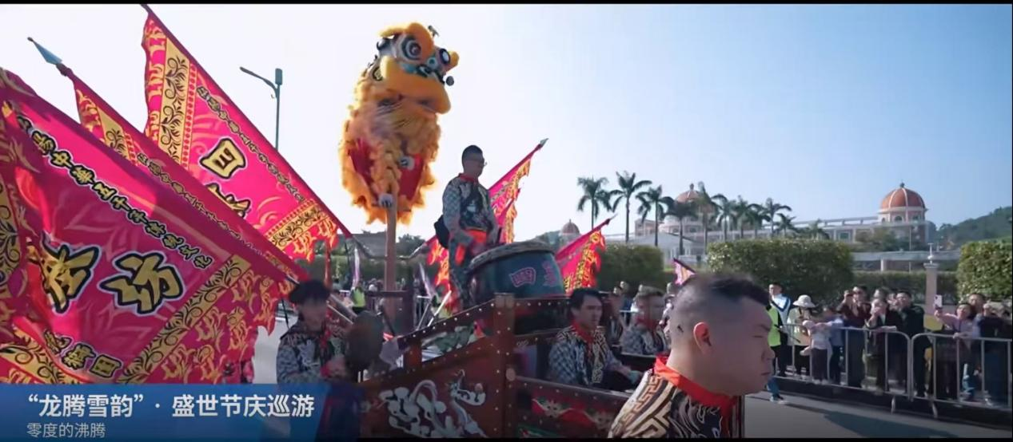
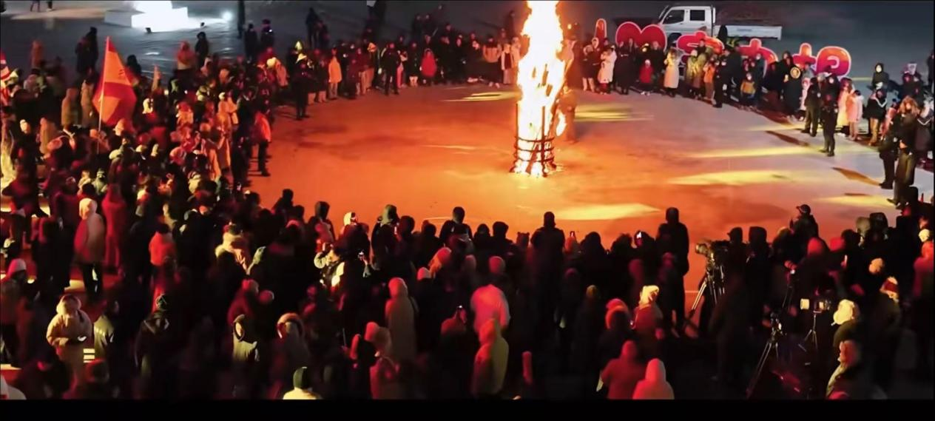
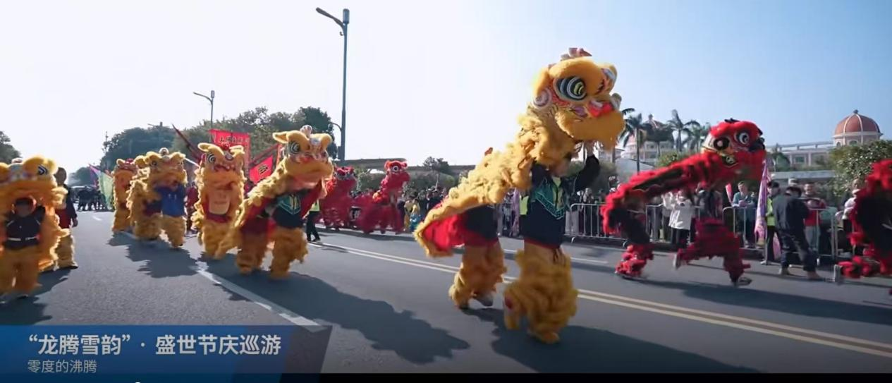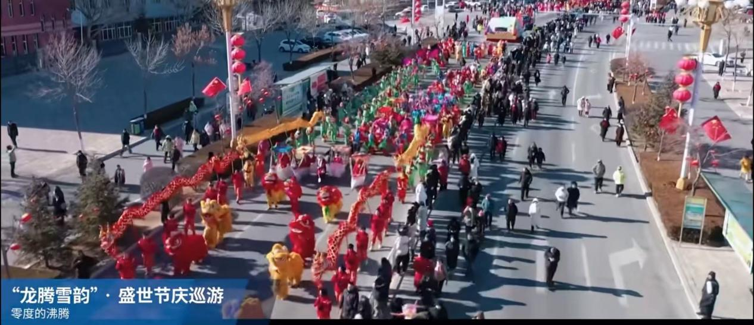
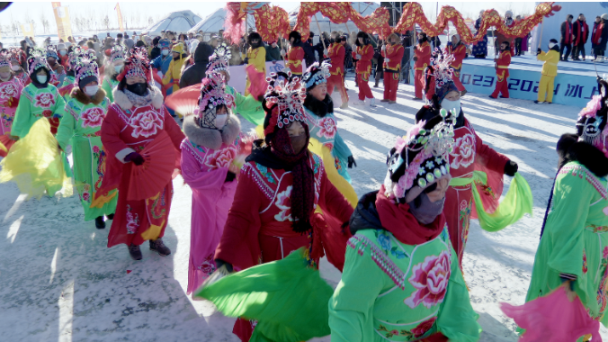

Transportation Methods：
Beijing Capital International Airport (Beijing Capital International Airport, IATA: PEK, ICAO: ZBAA) is located in Chaoyang District and Shunyi District of Beijing, China. It is 25 kilometers southwest of downtown Beijing and 67 kilometers south of Beijing Daxing International Airport. It is a 4F-class international airport, a world-class large international hub, China's first gateway, and a national gateway hub.
(After arrival, you need to transfer to a high-speed train for 1.5-2 hours to reach the Chao yang station) Then we will arrange pick up and drop off from the Chaoyang train station.

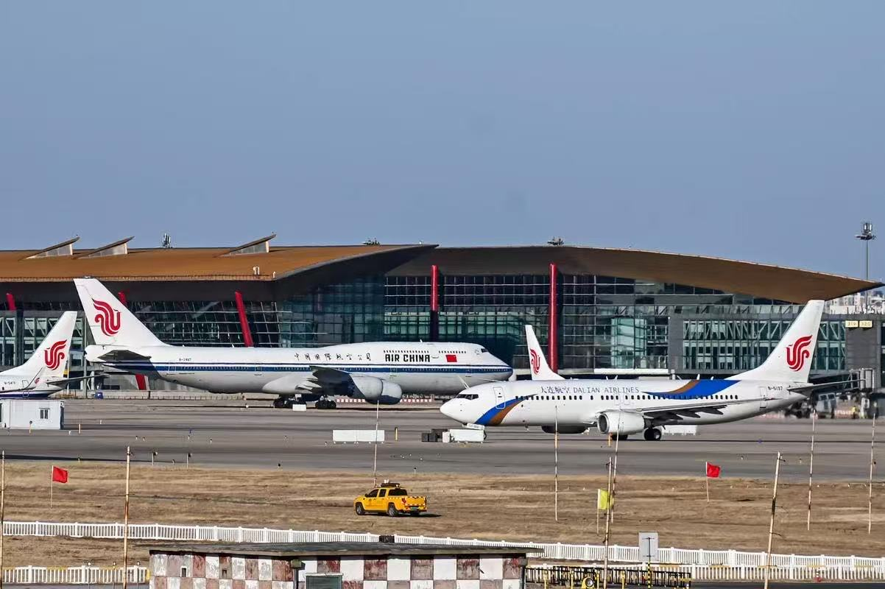
Shenyang Taoxian International Airport (Shenyang Taoxian International Airport, IATA: SHE, ICAO: ZYTX) is located in Taoxian Sub-district, Hunnan District of Shenyang, Liaoning Province, China. It is 20 kilometers away from downtown Shenyang. It is a 4E-class civil international airport, one of China's first-class trunk line airports, one of China's eight regional hub airports, and an air transportation hub in Northeast China.
(After arrival, you need to transfer to a high-speed train for 1.5-2 hours to reach the Chao yang station) Then we will arrange pick up and drop off from the Chaoyang train station.

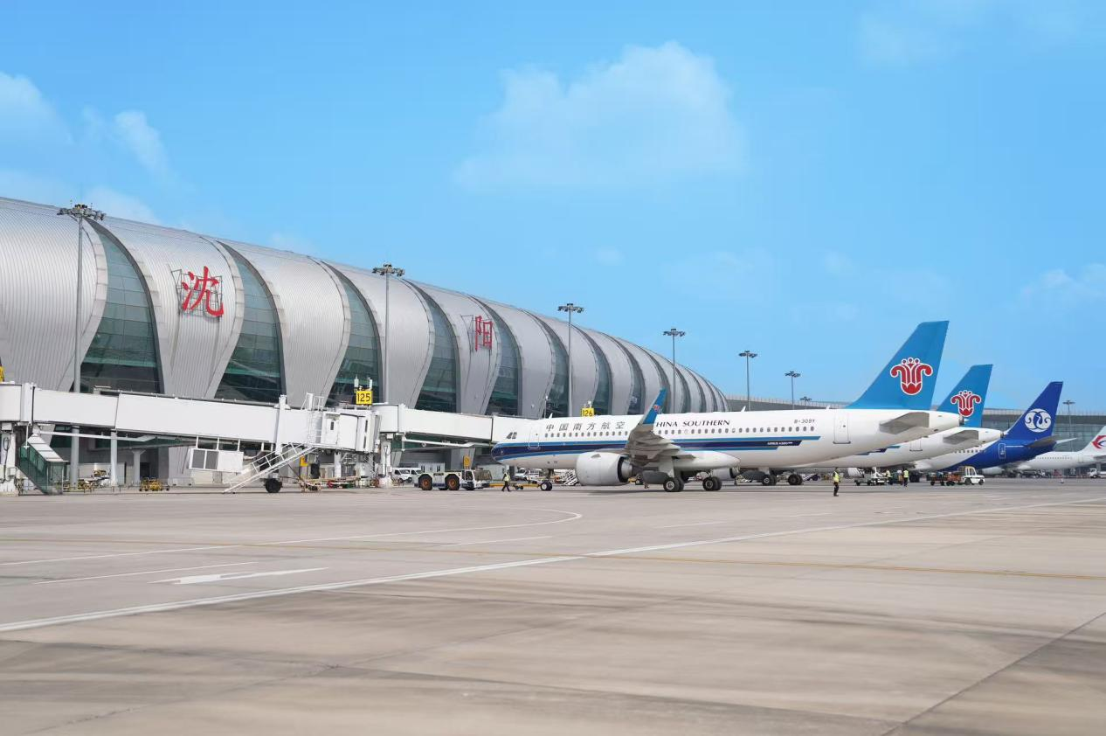

Catering & Accommodation：
Chaoyang Yandu International Hotel, Chaoyang Liaoning Province
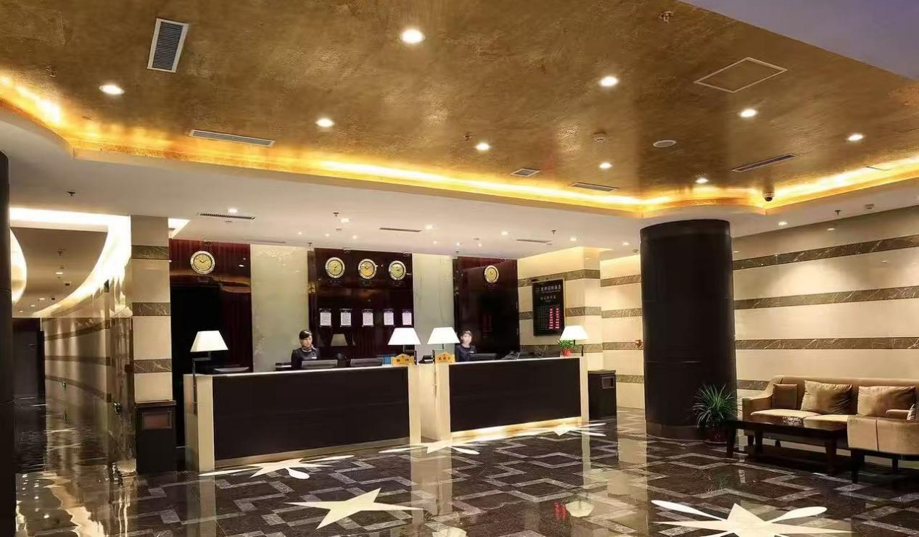
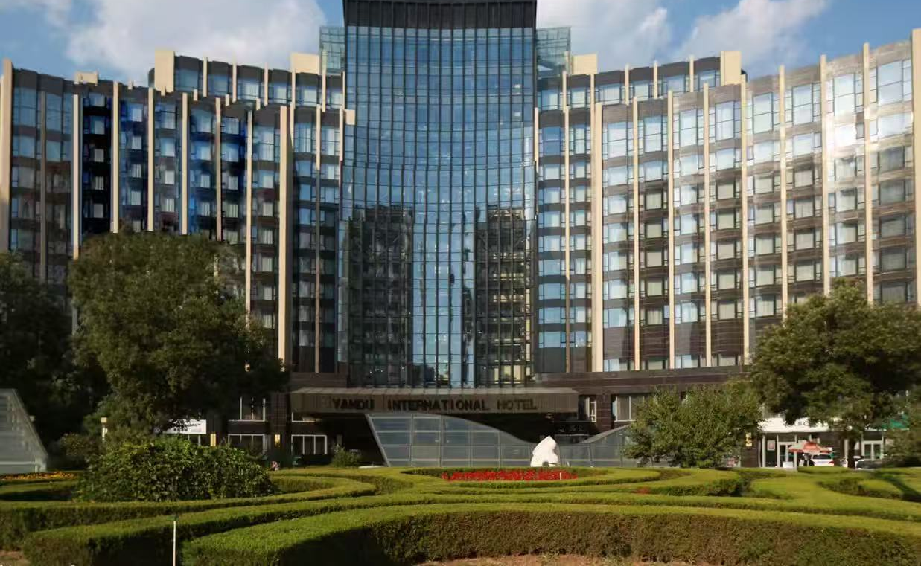
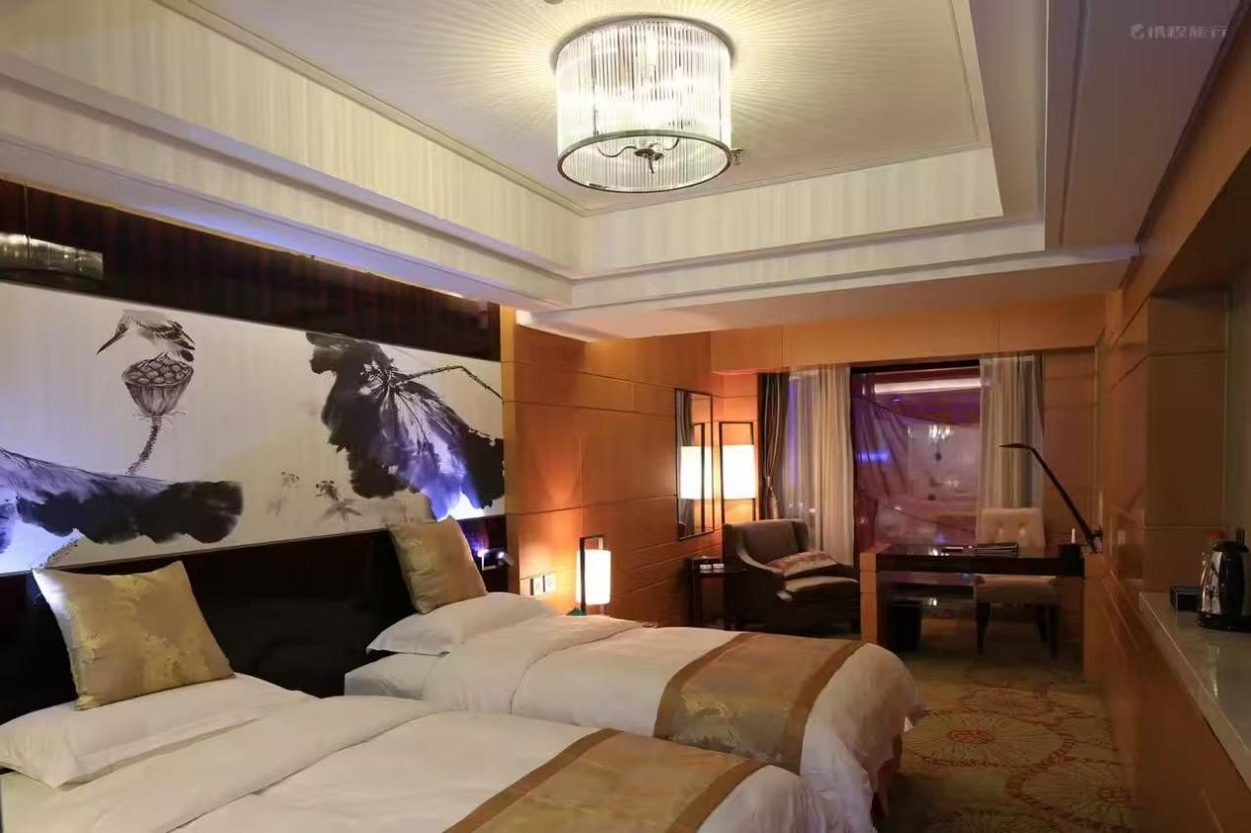

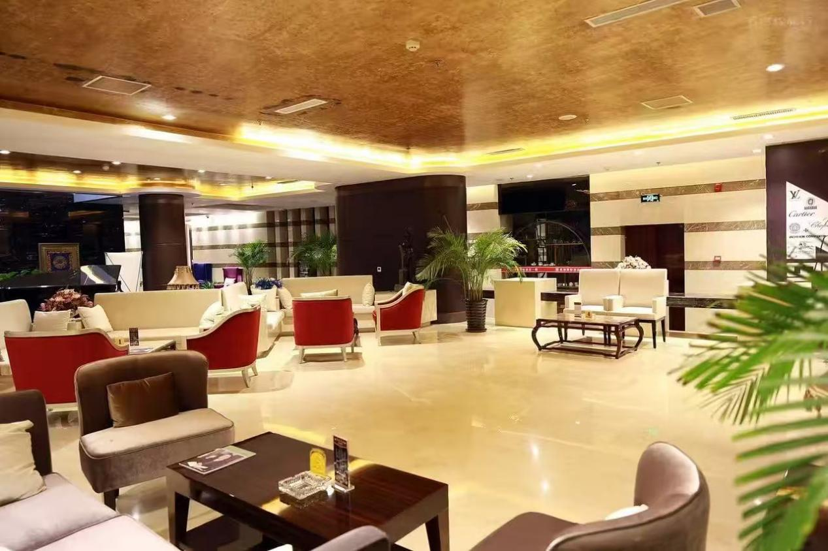

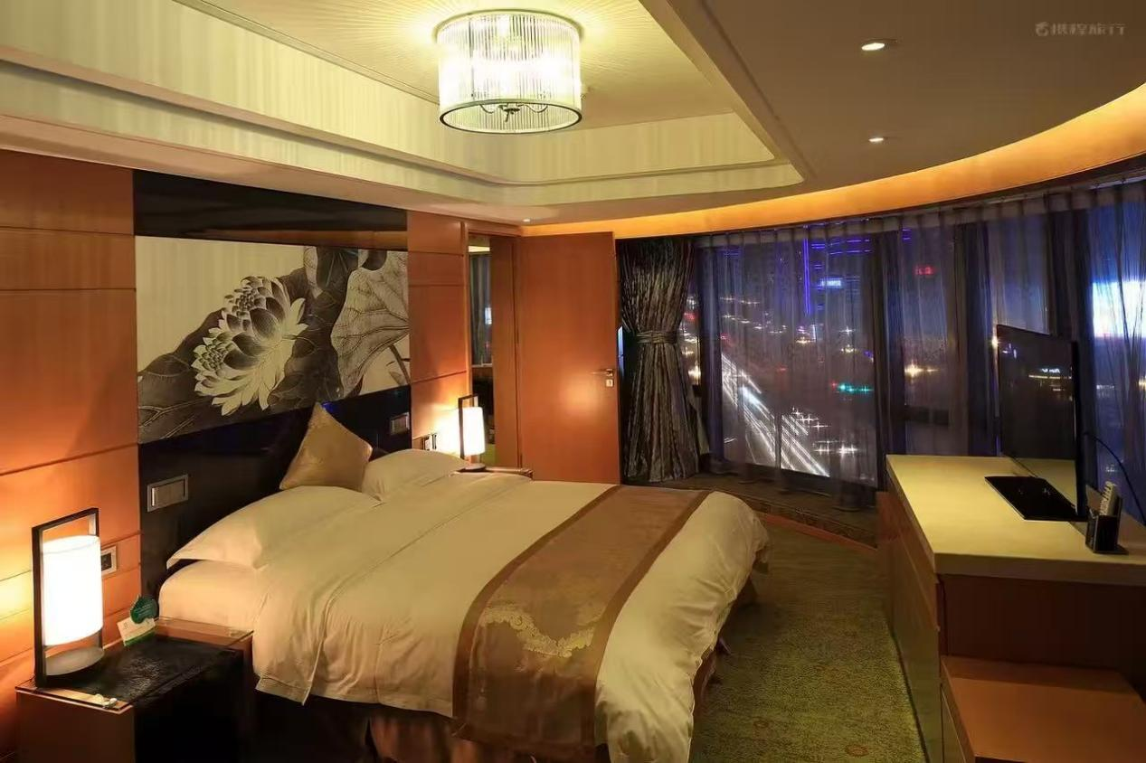

Tourism & Entertainment：
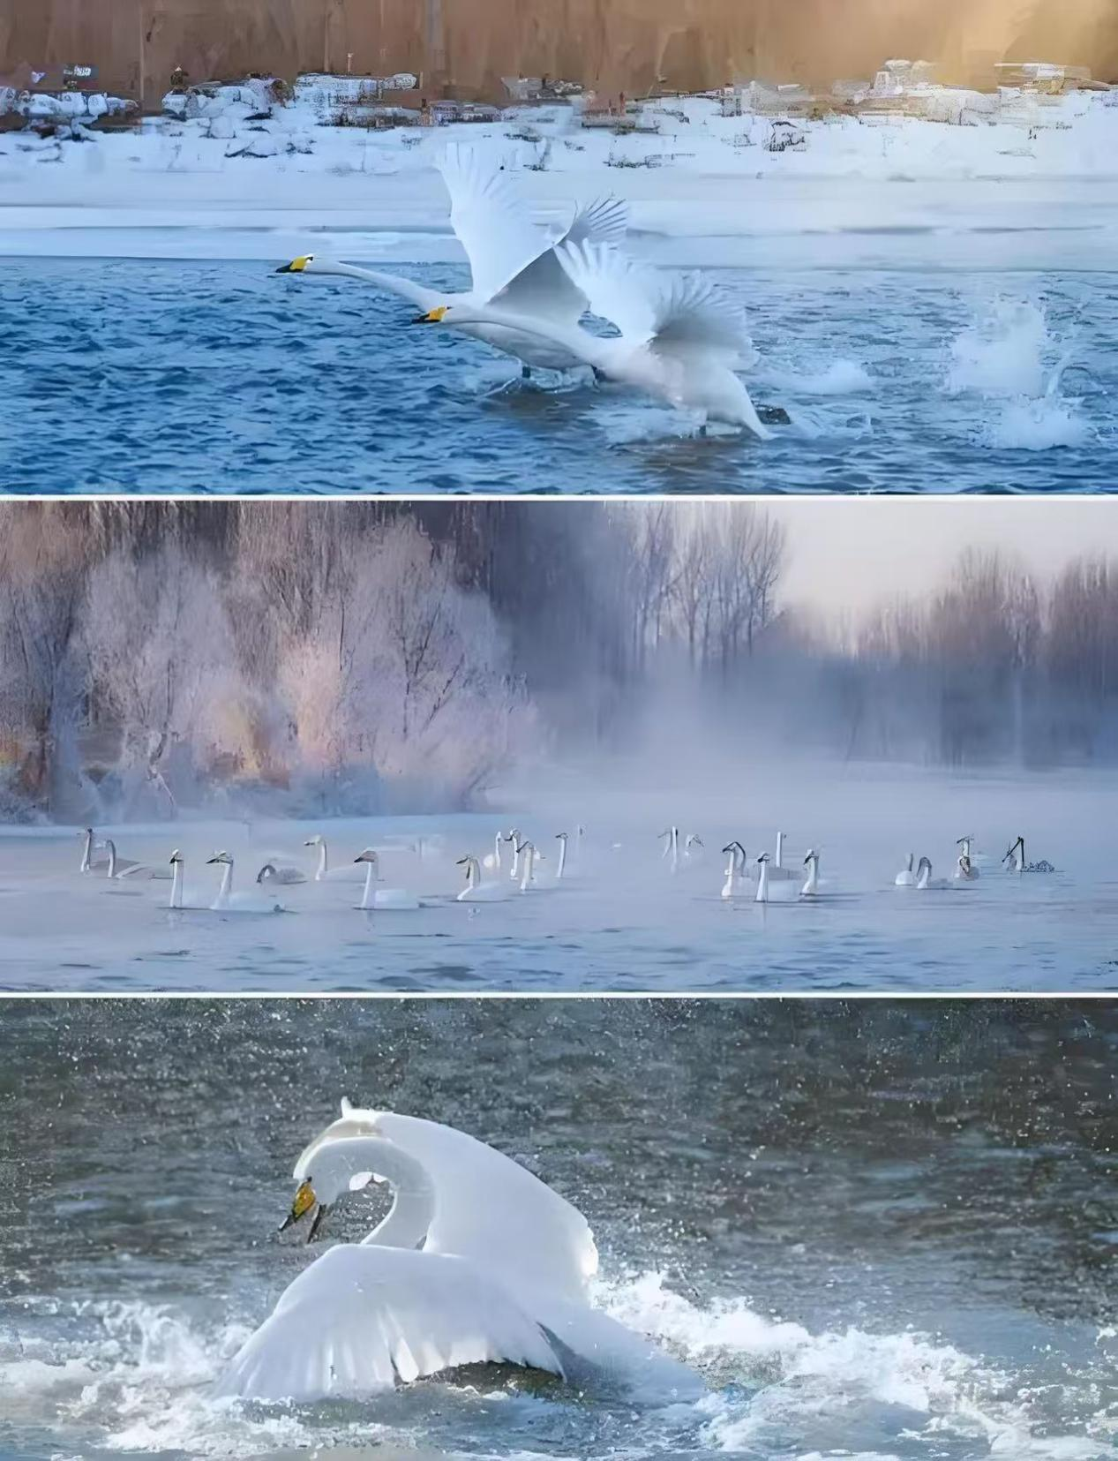

Winter wonderland
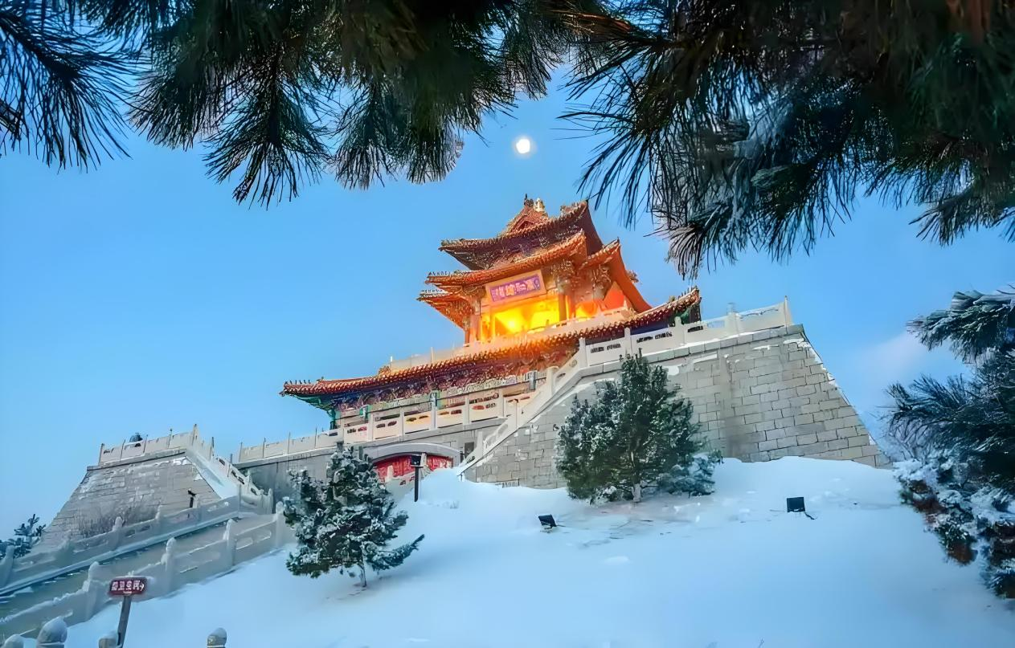
Historical Monuments

Local Specialty Cuisine：

Lingyuan Tofu Pudding

Kazuo Bowl - Shaped Jelly 
Jianping Glutionus Bean Bun 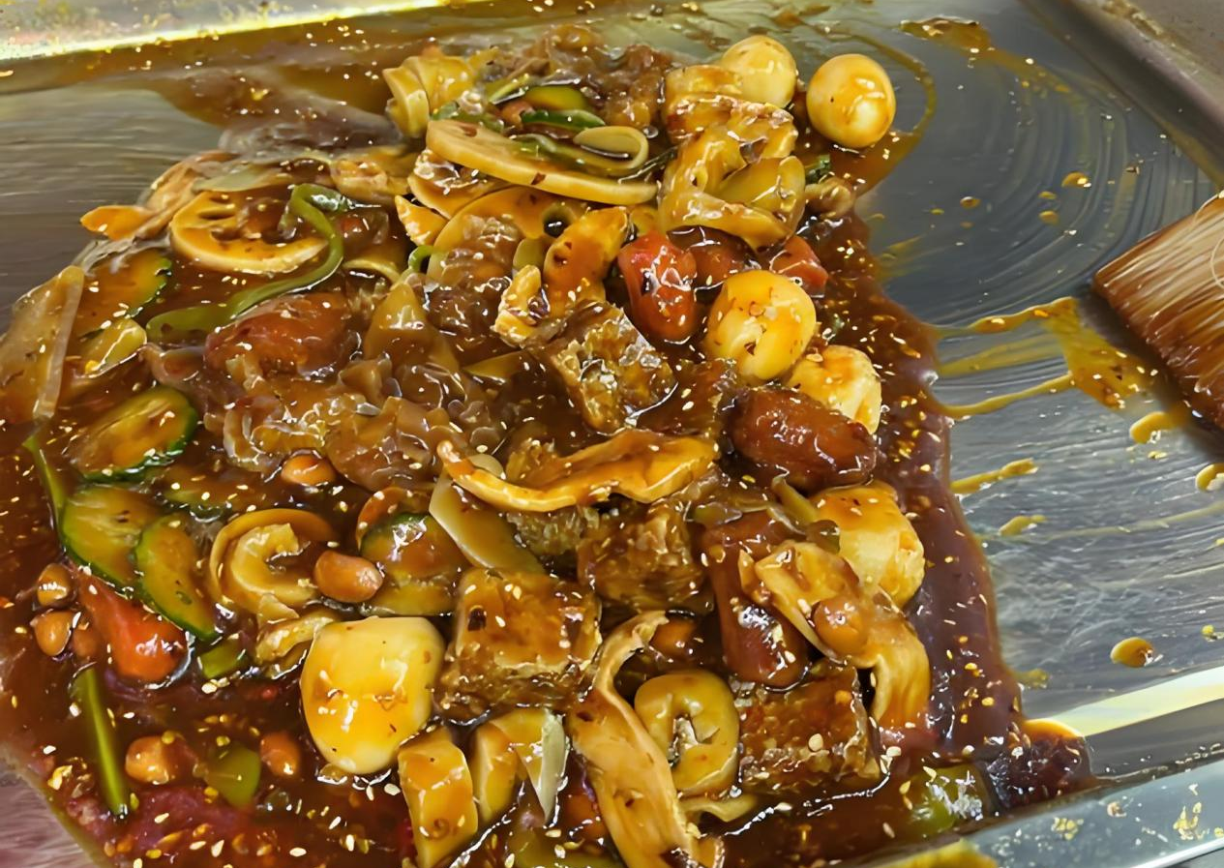
Spicy Skewers

Weather Forecast：
The average temperature in Chaoyang in December ranges from -6℃ to 4℃, with an average daytime temperature of about 4℃ and an average nighttime temperature of about -6℃.

Dressing advice is as follows: Upper Wear: It is recommended to wear heavy and warm clothing, including cotton-padded coats, winter overcoats, leather jackets, thick woolen coats and down jackets.

Trousers: Fleece-lined jeans, thick woolen pants or thermal pants can be chosen to keep legs warm.

Accessories: Woolen hats, gloves and scarves must be worn to prevent the head, hands and neck from getting frostbitten.

